Technical Story Card Revision History
Version No. | Date | Prepared by / Modified by | Significant Changes
1. | 10.02.2022 | Seema Singh | Introduction Added
2. | 13.02.2022 | Sweety Catherine | ER Diagram Added
3. | 15.02.2022 | Seema Singh | Use Case Model Added
4. | 16.02.2022 | Seema Singh | Process Model Added
6. | 23.02.2022 | Seema Singh | UI design pages screenshot added
7. | 24.02.2022 | Seema Singh | Scope of change added
8. | 26.02.2022 | Sweety Catherine | Sequence Diagram added
9. | 28.02.2022 | Sweety Catherine | Use-Case Model Description added
10. | 03.03.2022 | Sweety Catherine | Architecture Diagram added
11. | 04.03.2022 | Sweety Catherine | Class Diagram added
12. | 05.03.2022 | Sweety Catherine | Scope of Change modified
13. | 06.03.2022 | Sweety Catherine | Transaction Description added
14. | 07.03.2022 | Sweety Catherine | Welcome page description added
15. | 08.03.2022 | Sweety Catherine | Account Detail description added

Glossary
Abbreviation | Description
BSC | Business Story Card
TSC | Technical Story Card
DOJ | Date of joining

Table of Contents
1 Introduction 3
2 Scope of Change 3
3 List of impacted modules 3
4 Design and Detailed technical updates 4
4.1 Process model 4
4.1.1 Use case Model 4
4.1.2 Sequence diagram 4
4.1.3 Architecture diagram……………………………………………………….......................4
4.1.4 Class diagram………………………………………………………………....4
4.2 Proposed user Interface design 4
4.3 Database design changes 4
4.4 Refactoring related changes 4
4.5 Construction strategy and re-use 4
5 Details of Alternative Design Approach 4
6 Other Technical changes 5
6.1 Automation tasks / changes 5
6.2 CI / Build relates tasks / changes 5
6.3 Non-functional related changes 5
7 Additional details 5
7.1 Open Questions / clarifications / Assumptions 5
7.2 Additional notes to technical team 5
8 References 5

Introduction
The adoption of Electronic Banking by commercial enterprises has been in existence since the mid 90s, much greater in number due to lower operating costs associated with it. Electronic banking has initially been in the form of automatic teller machines and telephone transactions. More recently, it has been transfer made by the Internet, a new delivery channel for banking services that benefit customer. The bank management system is an application for maintaining an already existing customer's account in a bank. The system provides the access to the customer to deposit/withdraw the cash from his account, also to view reports of all accounts present.

Scope of Change
We can add registration for new user. We can include application for Loan in this project in the future. We can also include some other options like generating Bank statement in the form of pdf once they done the transaction.

List of impacted modules
All the functional modules will be created from scratch.

Design and Detailed technical updates
<Provide details of the Design/approach for developing/implementing the requirements>

Process model

Use case Model

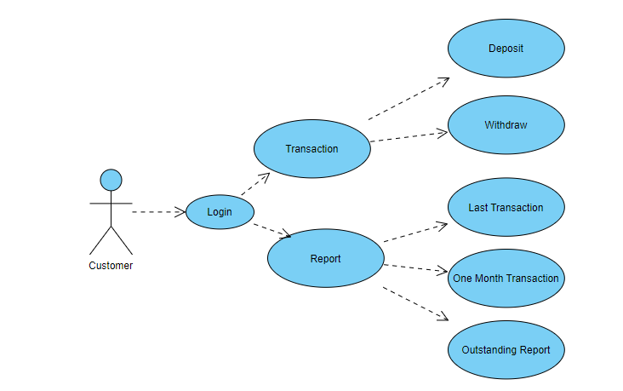

Brief Description | Customer operations in Bank Account
Basic Flow | Customer can login to the account  - Deposit Money  - Withdraw Money  - View the transaction report  Using any of these options customer will interact with the application. It will display the reports on last transaction, one month transaction and outstanding amount.
Alternate Flow | - The system will validate the information provided. If any invalid data is found, the input form will be redirected with error message.
Validation | - Balance amount is required minimum of Rs.1000.
Pre-Conditions | Customer should have network access and Browser with latest updates.
Post-Conditions | Success message should be shown.

Sequence diagram

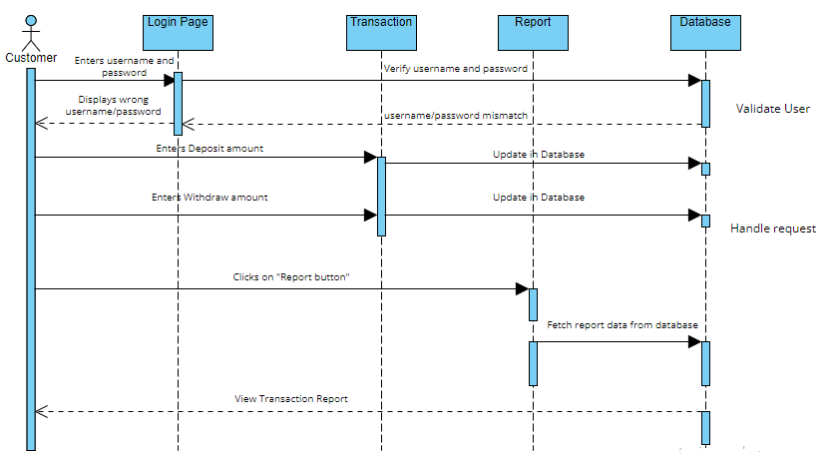

Architecture Diagram

Layer
Logical View
Technology/ Framework

UI Components
Login
Report
1.Last Transaction
2. 1 Month transaction
3.Outsatnding report

Presentation Layer
HTML/ CSS/ JavaScript/ AJAX/ Angular
Deposit

Withdraw

Web-Server Classes
Java 1.8/ Spring MVC
Application/ Business Layer
Configuration
Controllers

Service
REST Controllers

Entity/ Model Classes

Data Access Layer
Repository classes
Hibernate ORM

Oracle 11g Database

Presentation Layer:
This layer consists of all UI components.
- Login Component: Customers can use the login component to login to their respective accounts.
- Deposit Component: Customer can use the Deposit component to deposit an amount in his/her account
- Withdraw component: Customer can use the Withdraw component to withdraw an amount from his/her account
- Report component: By using Report component customer can get the report by either their last transaction or their monthly transaction or outstanding amount.

Application Layer:
This layer comprises of all server and business classes.
- Configuration settings (XML or Class based) will define the application and server configuration.
- Spring Controllers defines the server classes, which are required to process the incoming http requests.
- Service classes are required to perform the required business services.
- REST Controllers to process the HTTP AJAX requests.
- Model classes are used the define the functions of the entities present in the system.

Data Layer:
Data layer is implemented through Hibernate ORM. It will contain the repository classes, which provides interface to the table.

Class Diagram

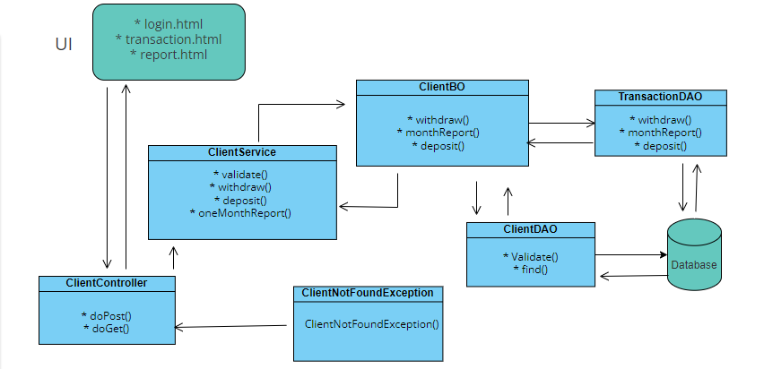

Proposed user Interface design
Login Page
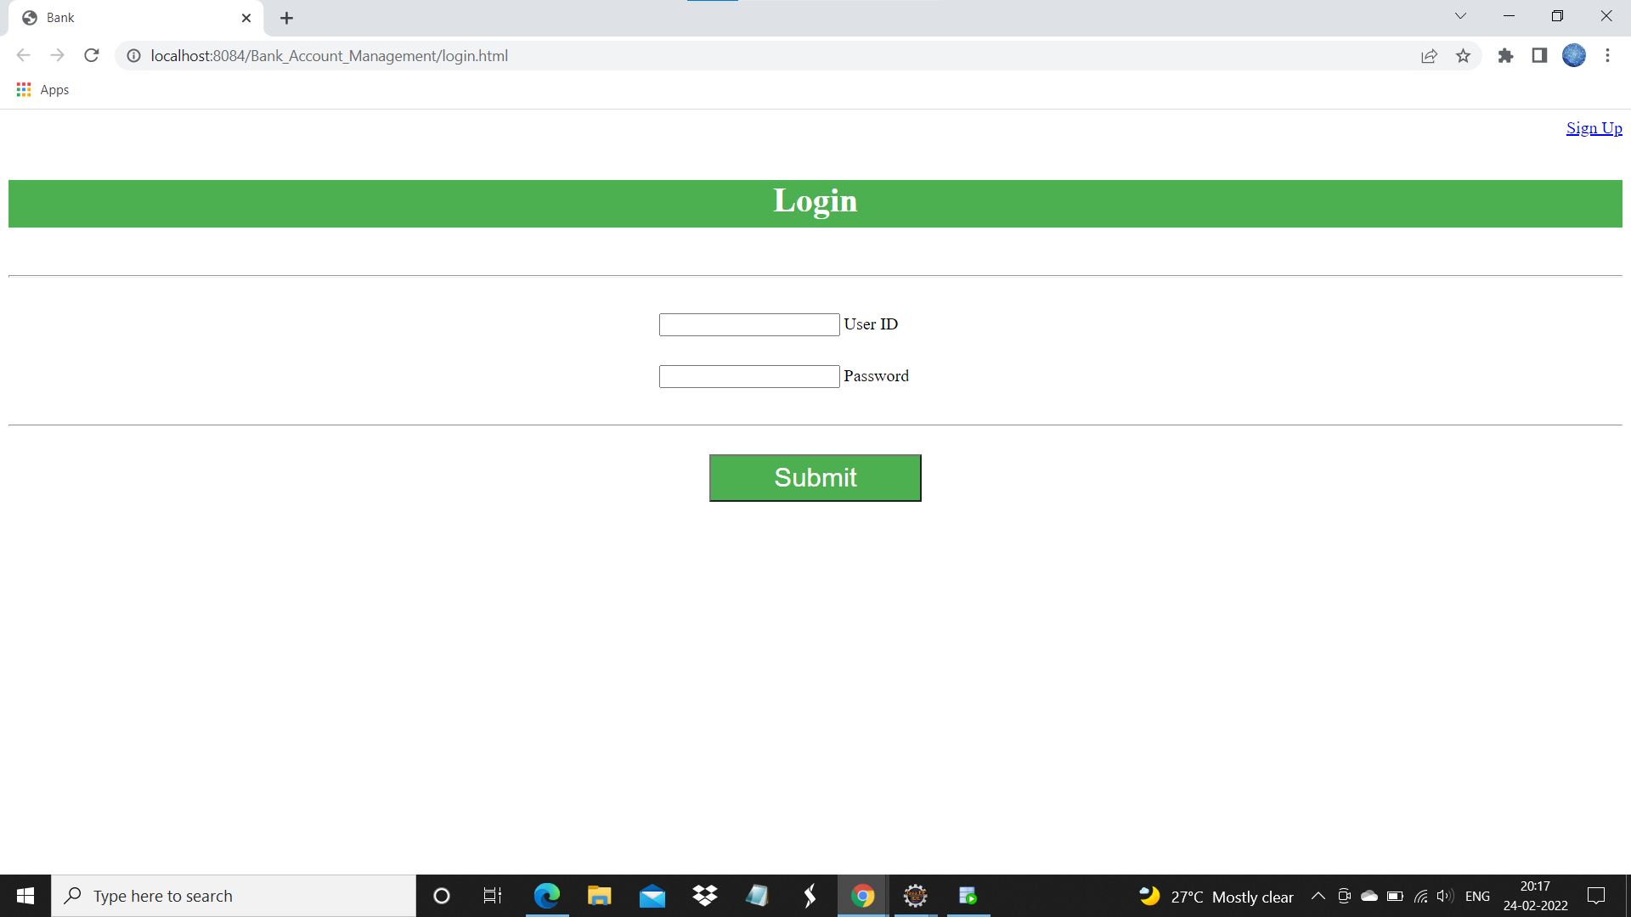

Brief Description | Login
Basic Flow | This page describes how a user log-in in to the system  - The customer has to login himself into the system.  - After the successful login, user will be taken to the appropriate landing page.  - The following information is required to login.  - username  - password
Alternate Flow | - The system will validate the credentials provided. If credentials are invalid, login form will be redirected again with error message.
Validation | - Valid username  - Valid password
Pre-Conditions | User should have network access and Browser with latest updates.
Post-Conditions | Welcome page has to be displayed.

Welcome Page
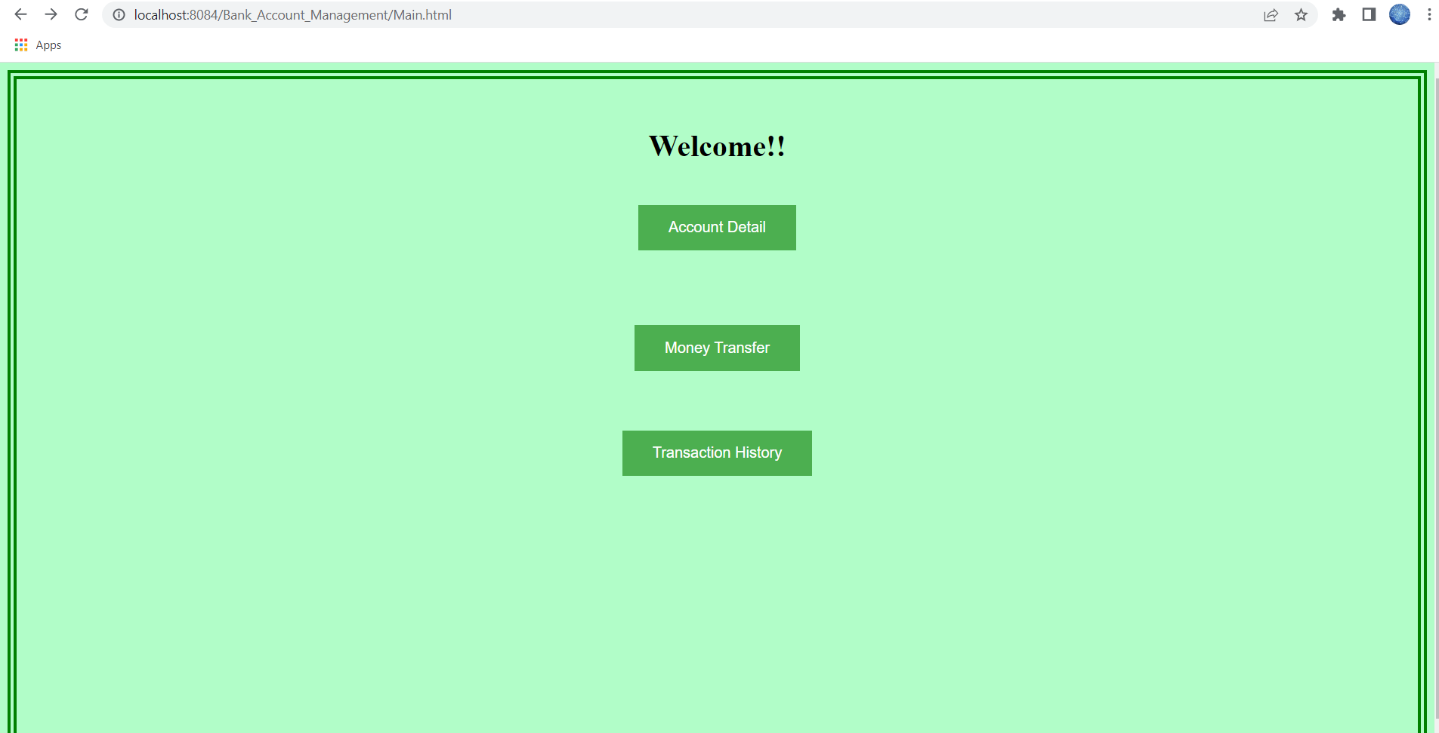

Brief Description | Welcome Page
Basic Flow | This page describes 3 options  1.The customer can view the account details.  2. The customer can do the money transaction.  3. The customer can view the details of his/her transaction by clicking Transaction History button.
Alternate Flow | The system will validate the credentials provided.
Validation | The amount entered should be in integer datatype.
Pre-Conditions | User should have network access and Browser with latest updates.
Post-Conditions | Transaction history/Transaction page has to be displayed.

Account detail
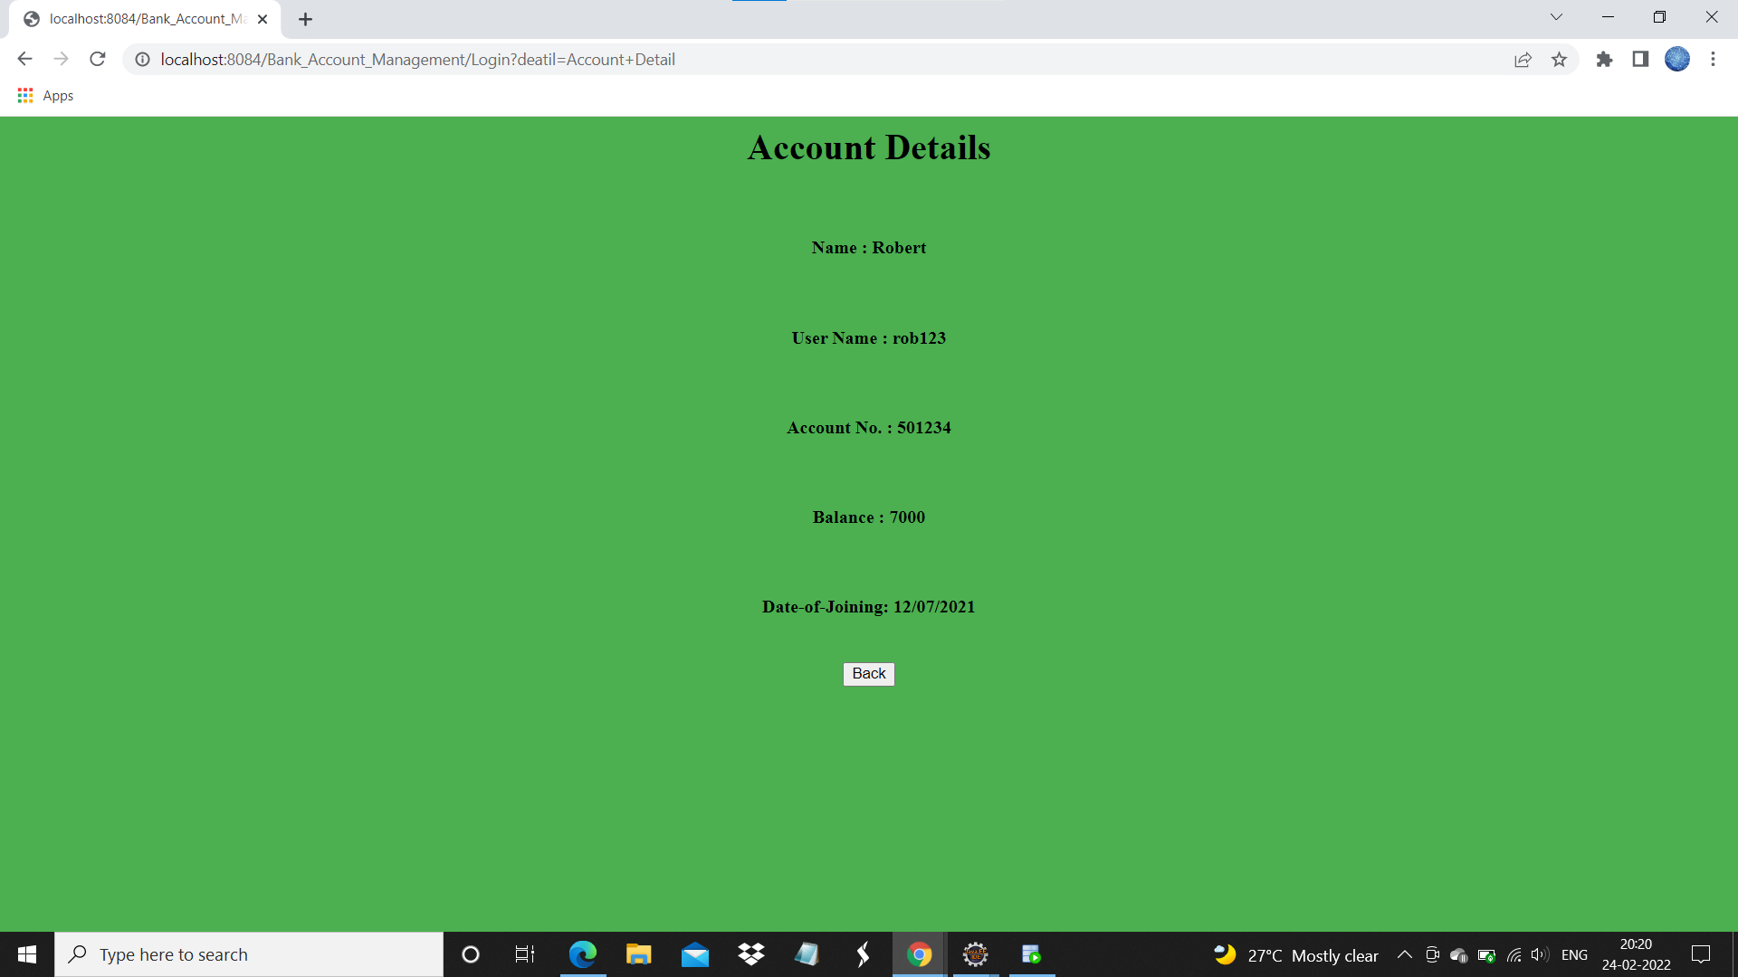

Brief Description | Account-Detail
Basic Flow | This page shows the customer account details. It contains:  1.Name of the Customer  2. Account number of the customer  3. Account balance  4. Date of joining
Alternate Flow | The system will validate the credentials provided.
Validation | The values entered should be valid data.
Pre-Conditions | User should have network access and Browser with latest updates.
Post-Conditions | By clicking “Back” button, Welcome page has to be displayed.

Transaction Page
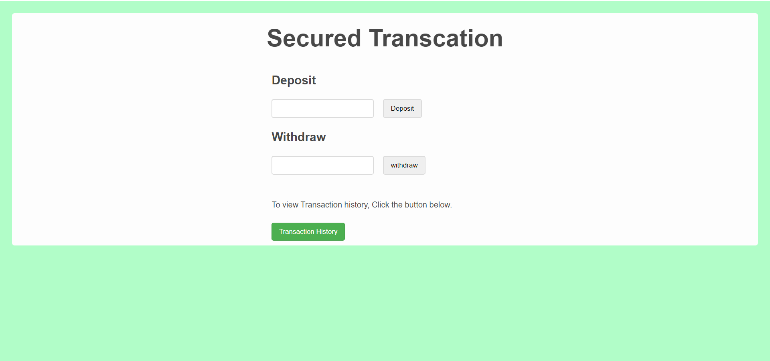

Brief Description | Transaction
Basic Flow | This page describes how a user do transaction process in his/her account.  1.The customer has to enter the amount that he/she wants to withdraw.  2. The customer has to enter the amount that he/she wants to deposit.  3. The customer can view the details of his/her transaction by clicking Transaction History button.
Alternate Flow | The system will validate the credentials provided.
Validation | The amount entered should be in integer datatype.
Pre-Conditions | User should have network access and Browser with latest updates.
Post-Conditions | Transaction history page has to be displayed.

Database design changes

ER Diagram

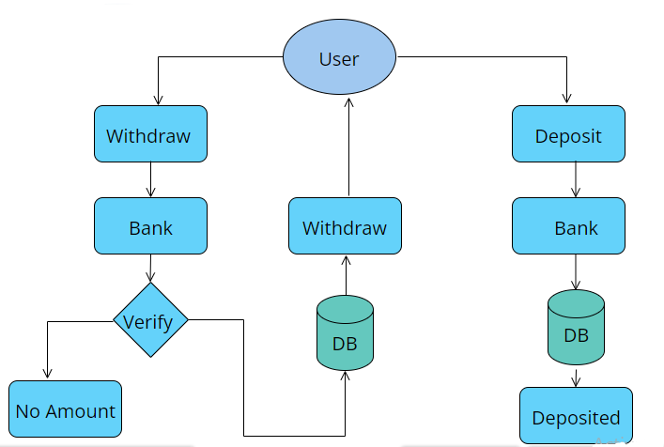

Refactoring related changes
<Mention details of code re-factoring requirements; objective and scope of re-factoring and Changes to be done >

Construction strategy and re-use
< Mention about automated code development (using code-generator) or manual coding. Also identify make/buy/reuse components involved, if any >

Details of Alternative Design Approach
<Details of the alternative approach to resolve the maintenance request>

Other Technical changes

Automation tasks
<if the story is about automation (of test cases or some POC etc.), mention the details here>

CI / Build relates tasks
<If the story requirements are about implementation of continuous integration or build, update the details to be done here>

Non-functional related changes
<Non-functional requirements related to response time, System load or Network load>

Additional details

Open Questions / clarifications / Assumptions
<Mention the details of any open technical questions/clarifications or assumptions made, pertaining to story >

Additional notes to technical team
<provide details if any>

References
< Provide reference details if any >

